2.84: a) In 3.0 seconds the teacher falls a distance

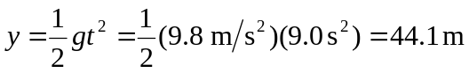
To reach her ears after 3.0 s, the sound must therefore have traveled a total distance of
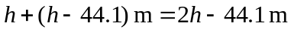,where h is the height of the cliff. Given 340 m/s for the speed of sound:, which gives 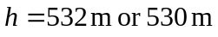to the given precision.
b) We can use 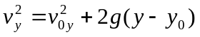 to find the teacher's final velocity. This gives 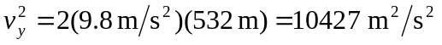 and 

